**Conceptual database design:**

Entity Relationship Diagram Design:

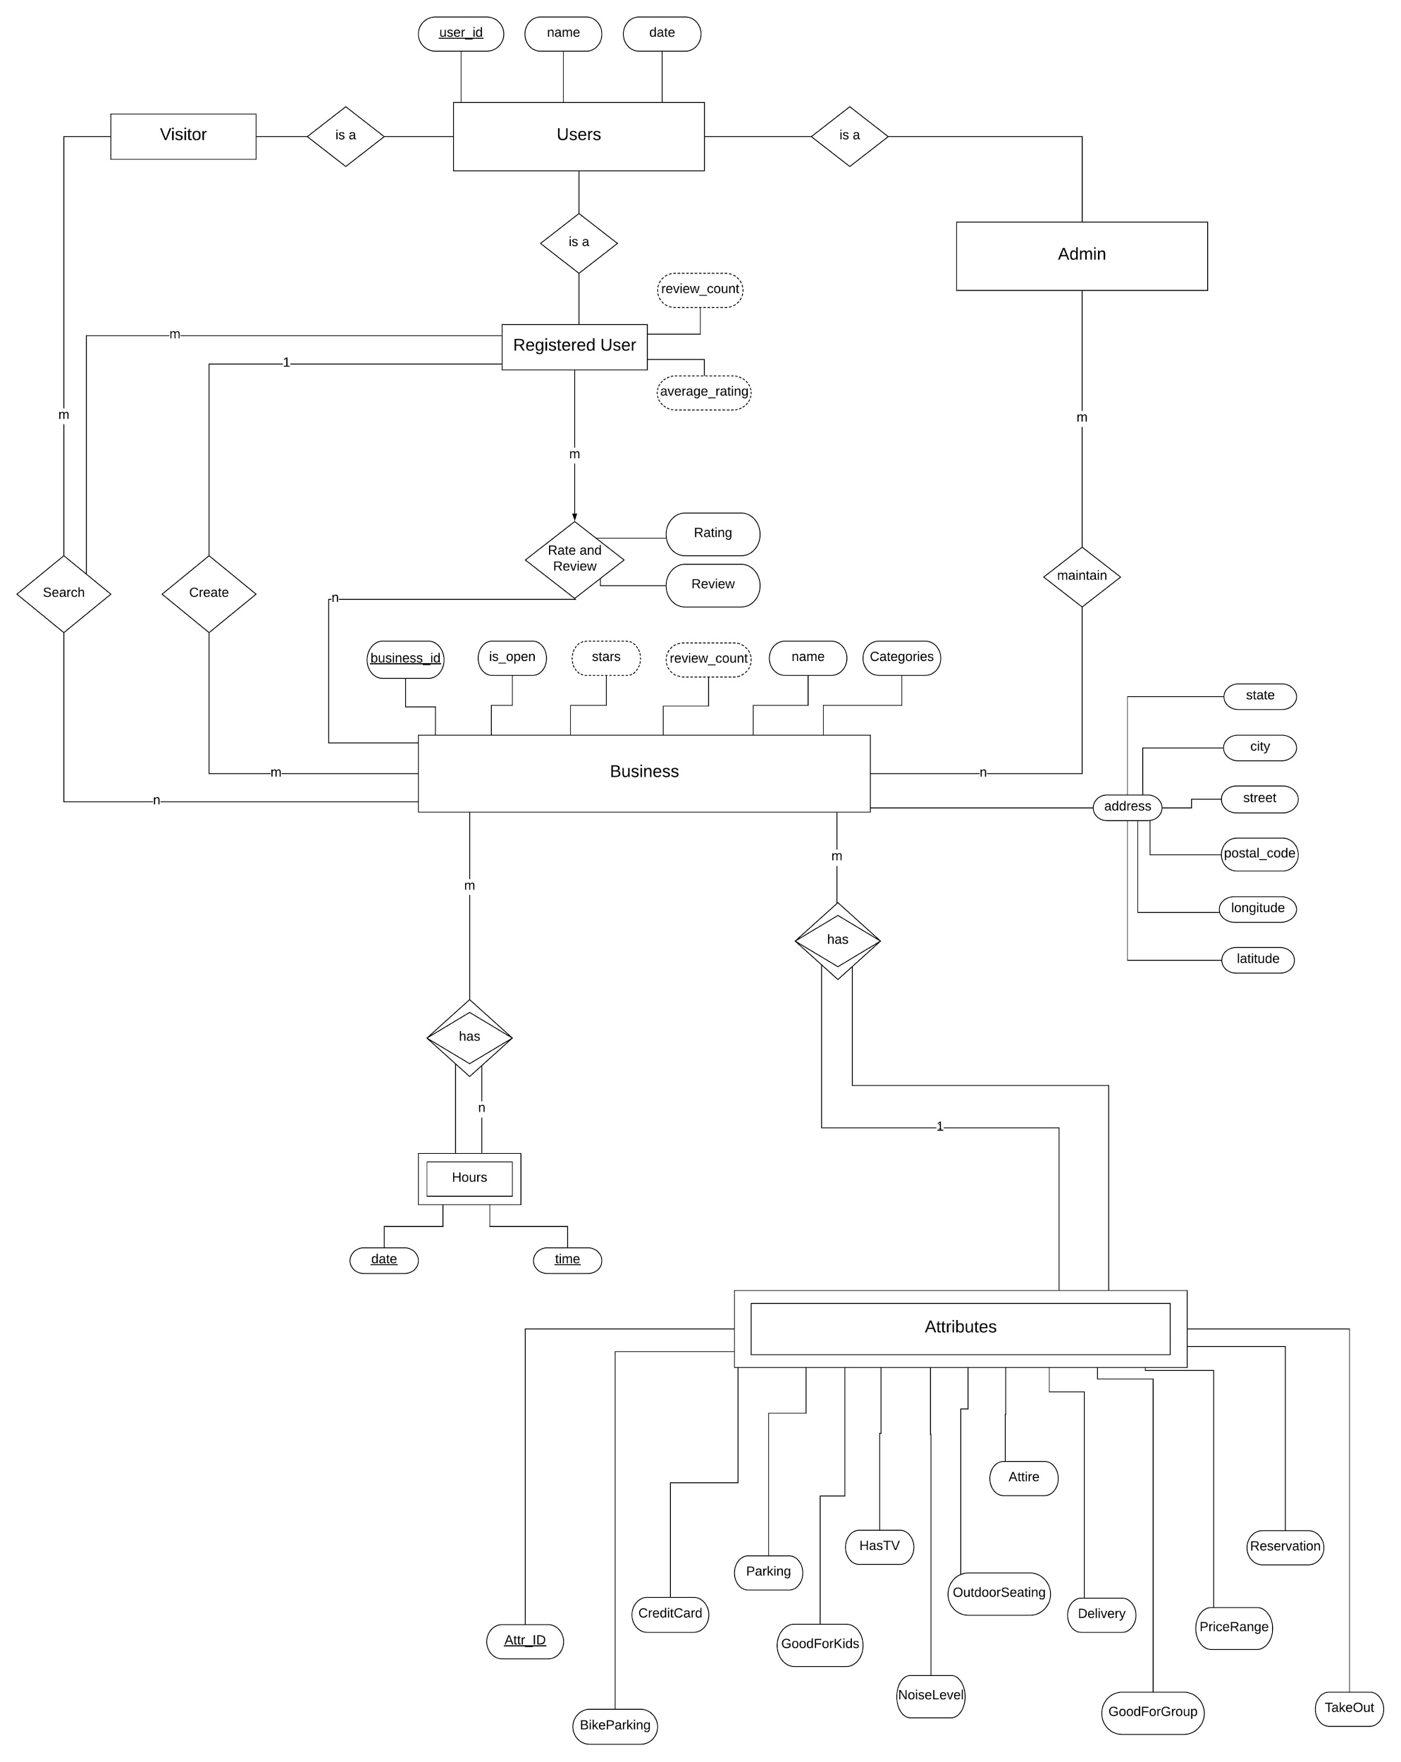

**ER Diagram Design Motivation:**

We designed this model based on the layout of data in the original datasets. Also, based on the type of users interaction with the data, it could be pure searching, creating their own business, rating and reviewing any business, or maintaining the data as admin.

**Important concepts of ER Diagram:**

ER Model is used to model the logical view of the system from data perspective.

Following are some important aspects of the ER Diagram:

* The above ER Diagram has four Entities : two strong entities and two weak entities.

Strong Entities are **Users**, **Visitor, Admin and Business,** .

Weak Entities are **Hours** and **Attributes**.

This is because ‘Hours’ and ‘Attributes’ entities are dependent on Business Entity.

* **Attributes:** The above ER Diagram has three type of attributes.
  + **Derived Attribute –** There are total four derived attribute in the ER Diagram.All are derived from rating and review.

They are : average_rating and review_count for the registered users entity, and stars and review_count for business entity.

* + **Composite Attribute –** The address is a composite attribute in the ER because it is composed of many other attributes like city state etc.
  + **Key Attributes –** The user_id and bussiness_id are the key attributes which uniquely identifies users and business entities in entity set respectively.

Likewise date and time are key attributes of hours entity and Attr_Id is key attribute of attributes entity.Although these are partial keys for this ER because attributes and hours entities are weak entities.

* **Participation Constraints:** In the ER Diagram ‘hours’ and ‘attributes’ entities has total participation with the business entity because they are weak entities.The participation of weak entity type is always total.
* **Cardinalities:**

* **(Registered User, Business): (m, n)**

One user can rate and review multiple businesses and create multiple business. One business can be rated and reviewed by many users and created by only one registered user.

* **(Visitor, Business): (m, n)**

One visitor can search many business and one business can be searched by many visitors.

* **(Admin, Business): (m, n)**

One admin can maintain many businesses and one business can be maintained by many admins

* **(Attributes, Business): (1, m)**

Each business has one attributes and each attributes can belong to multiple business.

* **(Business, Hours): (m, n)**

Each business has multiple opening hours and each opening hour can belong to multiple business.